**12장 과제**

2018312567 조명하

**1. pipe.c**

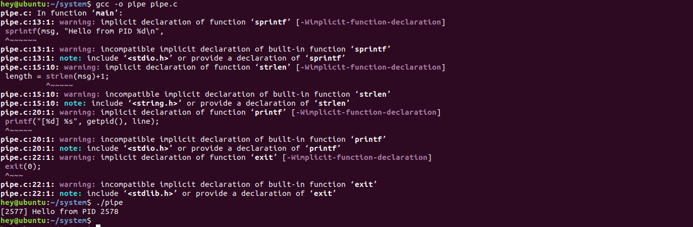

**2. stdpipe.c**

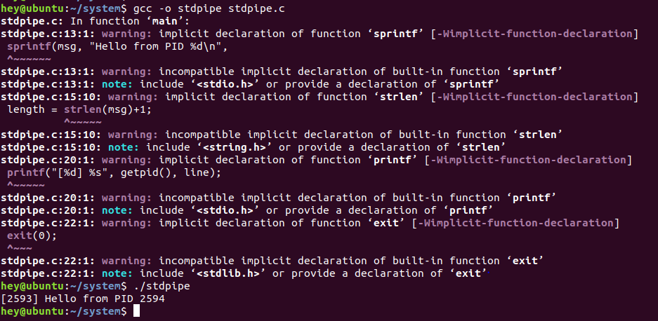

**3. pexec1.c**

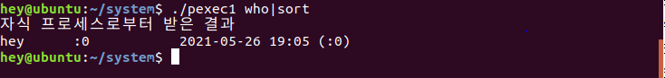

**4. shellpipe.c**

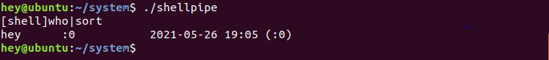

**5. pexec2.c**

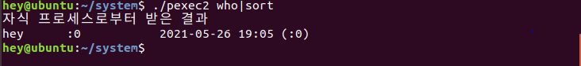

**6. npreader.c, npwriter.c**

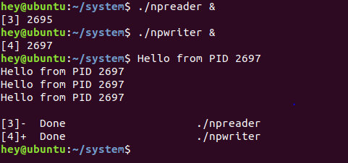

**7. chatserver.c, chatclient.c**

